The Wanderlust Book Tag!
I find this book while cruising through book blogs on Wordpress on theorangutanlibrarian’s website, I loved her response so I wanted to write one myself.
RULES
- Mention the creator of the tag and link back to original post [Alexandra@ReadingbyStarlight]
- Thank the blogger who tagged you
- Answer the 10 questions below using any genre
- Tag 5+ friends
THE QUESTIONS
Secrets and lies: a book set in a sleepy small town
Anne of Green Gables, to this day one of my favourite small-town reads; recommended to every teenage girl (and everyone else).
Salt and sand: a book with a beach-side community
The only ones that came to mind were Old Man and the Sea, and Twilight, so I picked Twilight.
Here there be dragons: a book with a voyage on the high seas
Instantly reminded me of The Chronicles of Narnia: The Voyage of the Dawn Treader.
Tread lightly: a book set down a murky river or a jungle
The Knife of Never Letting Go an awesome book that gripped my imagination immediately.
Frozen wastes: a book with a frost bitten atmosphere

The boonies: a book with ruff or isolated terrain
The Gann by R. Lee Smith
- Hinterlands and cowboys: a book with a western-esque setting
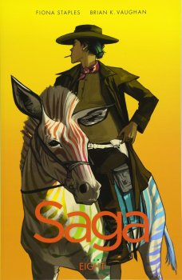
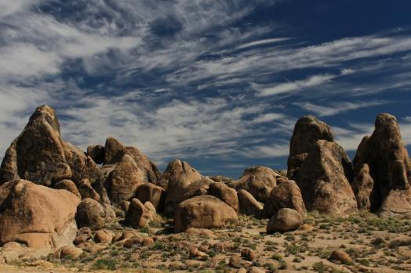
Saga Volume 8- okay, I did pick this largely cos I don’t really read books with this setting- BUT this is an excellent (adult) graphic novel- so if you like the look of it you should definitely check it out!
- Look lively: a book set across sweeping desert sands
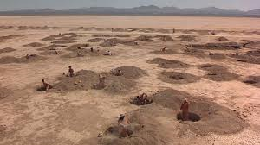
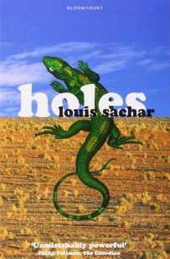
Holes- I am so glad I was reminded of this book by doing this tag, because it’s brilliant! A gripping story, with wonderful characters, about changing your fate.
- Wild and untamed: a book set the heart of the woods
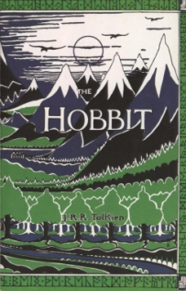
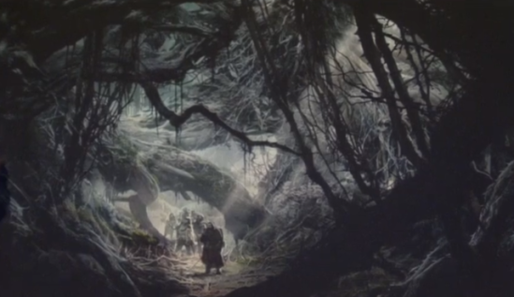
The Hobbit- okay, not all of this is set in woods, but for me Mirkwood is the most memorable fictional forest.
- Wildest dreams: a whimsical book shrouded in magic
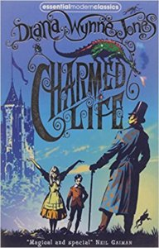
Charmed Life- yes, yes I could’ve gone with Harry Potter- but you guys know it already. If you’re looking for something else that’s whimsical, you can’t go wrong with Diana Wynne Jones- I especially love the Crestomanci series!
That was a lot of fun! I tag: Miri @the Book Dragoness, Zezee with Books, Embuhleeliest, Read by Tiffany, Meeghan, Ola and Piotrek @Re-Enchantment of the World Blog, the Corner of Laura and anyone else who wants to do it!
What did you think of my answers? And what are some of your favourite books for these settings? Let me know in the comments!

